# Title of the contribution

Name’s initial letter and surname1, N. Surname2, *, N. Surname3...

1 Institution, City, Country, e-mail, **[](https://orcid.org/0000-0000-0000-0000)**; 2 Institution, City, Country, e-mail, **[](https://orcid.org/0000-0000-0000-0000)**; 3 Institution, City, Country, e-mail, **[](https://orcid.org/0000-0000-0000-0000)**

Topic: Choose a topic from the dropdown list by clicking on this text.

**How to cite:** Surname, Name; Surname, Name and Surname Name (2025). Title of the contribution. In proceedings book: *HERITAGE 2025 | International Conference on Earthen and Vernacular Heritage: Conservation, Adaptive Reuse and Urban Regeneration.* September 10th – 12th, 2025, Valencia (Spain). https://doi.org/10.4995/HERITAGE2025.2025.****

**Abstract**

A single paragraph of about 300 words maximum, using Times New Roman italic size 9. Authors are encouraged to use the following structure: set out the background of the issue, briefly describe the main methods, summarize the main findings, and indicate the key conclusions. The abstract should objectively represent the paper and must not include results that are not presented and substantiated in the main text.

**Keywords:** keyword 1, keyword 2… (list four to six pertinent keywords)

## 1. Introduction

The template details the guidelines to be used in the papers for HERITAGE2025 International Conference on Earthen and Vernacular Heritage: Conservation, Adaptive Reuse and Urban Regeneration. Due to the high standards of the publication, the Organizing Committee requests the authors to follow the provided template rigorously and invites all the participants to consider the key deadlines published on this site.

Contributions must be a minimum of 6 pages and a maximum of 8 pages. The organization would appreciate an even number of pages (whether 6 pages or 8 pages). Otherwise, the layout might be altered by increasing the figures or other elements to achieve uniformity in the distribution of pages of the final printed version. The established page dimensions are 17 x 24 cm in vertical position, with margins of 2.4 cm on the top and bottom edges, 2 cm on the inside and 1.6 cm on the outside edge.

Please do not modify these dimensions, as the entire document will require later formatting to match the rest of the contributions. All text, figures and tables must be included within the margins of the template.

For convenience, styles for each section have been generated and are available in the “Styles” menu of Microsoft Word. The paragraphs must be in Times New Roman font size 9 points, justified and arranged in two columns of 6.2 cm width and 1 cm of space in between, as it appears in this template. The spacing between lines should be 1.15 cm, with a previous and posterior spacing of 6 pt.

Please, properly complete and check the details of the authors: name, institution, country, email and link to the ORCID profile (by linking the associated image).

## 2. Headings and subheadings

The contribution should include an introduction, objectives, methodology, results, discussion and conclusions. It is not mandatory to follow this structure, although it is recommended to include such proposed information.

### 2.1. Subsection

Contributions must be structured using sections and subsections consecutively numbered, as shown in this template.

#### 2.1.1. Subsubsection

Subsections and subsubsections can be added consecutively numbered using the corresponding text styles for each type.

## 3. Other elements: figures, tables, etc.

### 3.1. Figures

Text may include images, tables, graphs and formulas, following the guidelines below. These elements will be shown in colour in both the digital and the printed versions, although it is advisable to have adequate quality for understanding.

Figures should be cited in the text and stated consecutively, using an abbreviated expression and number like the one at the end of this phrase (Fig. 1). Each figure must include that abbreviated expression with the number, a brief description and the source or original authorship.It is advisable to include the figures between the frames of their corresponding columns, respecting the general margins of the template.

The figures should be placed in line with the text, using the corresponding option of Microsoft Word and should use the style “H2025_Fig caption” available at the styles tab of Microsoft Word.

Fig. 1 - *Example of caption* (James Manson, 2005).(column image width: 6,2cm)

In the case of a more horizontal or more significant figure, it is possible to occupy the entire space of the two columns as long as the general margins of the template are respected. In this case, it would be necessary to include a continuous section break after and before the figure, changing the number of columns to one. We encourage the authors to copy and edit the example found below (Fig. 2). Also, placing this kind of figure at the top or bottom of the pages is advisable.

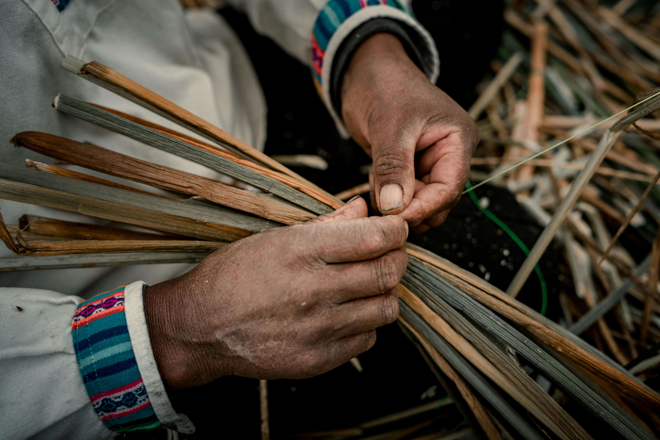Fig. 2 - *Example of caption and figure that occupies two columns.* (full image width: 13,4cm)

### 3.2. Formulas and equations

Simple equations can be placed in the text using the options of superscript and subscript available in the Format Menu of Microsoft Word. From the above, we note that A = π r².

Complex formulas and equations should be inserted using the integrated equation editor available in Microsoft Word, as shown in Equation 1.

$w=\frac{M}{Q}\left\{\frac{\sin\left[k\left(h-x\right)\right]}{\sin\left(kh\right)}+\frac{x}{h}-1\right\}$ (1)

Number equations consecutively and place the number with the tab key at the end of the line, between parentheses. Refer to equations by these numbers.

### 3.3. Units and measures

To ensure consistency and clarity across all submissions, authors are required to use the International System of Units (SI) in their contributions.

Use a comma to separate thousands (e.g., 1,000; 10,000) and a period (decimal point) for decimal fractions (e.g., 3.14; 2.75). This follows standard English notation, which differs from other languages that may use periods for thousands and commas for decimals.

### 3.4. Quotes

For direct quotations of fewer than 40 words, add English quotation marks (“text”) around the words, incorporate the quote into your text and add the reference at the end. For example: Effective teams can be difficult to describe because “high performance along one domain does not translate to high performance along another” (Ervin et al., 2018, p. 470).

For quotations of 40 words or more, do not use quotation marks to enclose it. Instead, start a block quotation on a new line and indent the whole block 0.5 cm from the left margin. Please, remember that there is style available for this kind of text.

Inner speech is a paradoxical phenomenon. It is an experience that is central to many people’s everyday lives, and yet it presents considerable challenges to any effort to study it scientifically. Nevertheless, a wide range of methodologies and approaches have combined to shed light on the subjective experience of inner speech and its cognitive and neural underpinnings. (Alderson-Day & Fernyhough, 2015, p. 957)

### 3.5. Tables

Tables should be cited in the text and stated consecutively (Table 1). Tables should have a title or caption above them, numbered independently from the figures and following the example below:

Table 1 - *Titles and data* (author, 2024).

|  |  |  |
| --- | --- | --- |
| **Title 1** | **Title 2** | **Title 3** |
| **entry 1** | data | data |
| **entry 2** | data | data |
| **entry 3** | data | data |

If a table contains large data, the entire page width can be used using the format shown on the following page. Please try to place any full-page figures or tables at the top or bottom of the page (Table 2).

Table 2 - *Titles and data* (author, 2024).

|  |  |  |  |  |
| --- | --- | --- | --- | --- |
| **Title 1** | **Title 2** | **Title 3** | **Title 4** | **Title 5** |
| **entry 1** | data | data | data | data |
| **entry 2** | data | data | data | data |
| **entry 3** | data | data | data | data |
| **entry 4** | data | data | data | data |

### 3.6. Listing and numbering

It is possible to use a numbered or bulleted list following the styles presented below to present a list of data, results or facts. It is recommended to introduce the lists using an explanatory paragraph previously.

Bulleted lists should look like this:

* First bullet;
* Second bullet;
* Third bullet;

Numbered lists can be added as follows:

1. First item;
2. Second item;
3. Third item;

The text continues here.

### 3.7. Footnotes

Footnotes should be reduced to the essential minimum, containing additional information that is considered appropriate. They are not proposed as a method to include references, which must follow the APA 7th edition system.

Footnotes should be numbered in order of appearance and superscript[1], inserted using the option available in the Footnotes menu of Microsoft Word.

## 4. Guidelines for references: APA 7th ed.

References should follow the standards established by the APA style 7th edition; more information can be found at https://apastyle.apa.org/.

Specific examples can be found at: https://apastyle.apa.org/style-grammar-guidelines/references/examples

APA Style uses the author–date citation system, in which a brief in-text citation directs readers to a full reference list entry.

The in-text citation appears within the body of the paper and briefly identifies the cited work by its author and date of publication. This enables readers to locate the corresponding entry in the alphabetical reference list at the end of the paper.

Authors are encouraged to include only those references that have been specifically mentioned in the text. The list of references should be included at the end of the manuscript, alphabetically arranged.

Therefore, author-date citation system must be used to cite references in the text. Use an ampersand (&) between names for a work with two authors. For a work with one or two authors, include the author’s surname(s) in every citation (Hygum & Pedersen, 2010). For a work with three or more authors, include the name of only the first author plus “et al.” in every citation (Grady et al., 2019).

Fundings

In this section the authors can reflect the possible funding received. Feel free to delete it if you have not received any funding. Please, remember to check the spelling of the funding organizations and include the aid number or reference, if considered necessary.

Acknowledgements

In this section, authors can acknowledge any support given which is not covered by the funding section. This may include administrative and technical support, or donations in kind. Please, feel free to delete this section if considered unnecessary

References

Aron, L., Botella, M., & Lubart, T. (2019). Culinary arts: Talent and their development. In R. F. Subotnik, P. Olszewski-Kubilius, & F. C. Worrell (Eds.), *The psychology of high performance: Developing human potential into domain-specific talent* (pp. 345–359). American Psychological Association.

Dillard, J. P. (2020). Currents in the study of persuasion. In M. B. Oliver, A. A. Raney, & J. Bryant (Eds.), *Media effects: Advances in theory and research* (4th ed., pp. 115–129). Routledge.

Grady, J. S., Her, M., Moreno, G., Perez, C., & Yelinek, J. (2019). Emotions in storybooks: A comparison of storybooks that represent ethnic and racial groups in the United States. *Psychology of Popular Media Culture*, 8(3), 207–  217.   https://doi.org/10.1037/ppm0000185

Hygum, E., & Pedersen, P. M. (Eds.). (2010). *Early childhood education: Values and practices in Denmark.* Hans Reitzels Forlag.

Jerrentrup, A., Mueller, T., Glowalla, U., Herder, M., Henrichs, N., Neubauer, A., & Schaefer, J. R. (2018). Teaching medicine with the help of “Dr. House.” *PLoS ONE*, *13*(3), Article e0193972. https://doi.org/10.1371/journal.pone.0193972

Miranda, C. (2019). *Exploring the lived experiences of foster youth who obtained graduate level degrees: Self-efficacy, resilience, and the impact on identity development* [Doctoral dissertation, Pepperdine University]. PQDT Open. https://pqdtopen.proquest.com/doc/2309521814.html?FMT=AI

National Cancer Institute. (2019). *Taking time: Support for people with cancer* (NIH Publication No. 18-2059). U.S. Department of Health and Human Services, National Institutes of Health.

Sapolsky, R. M. (2017). *Behave: The biology of humans at our best and worst*. Penguin Books.

Torino, G. C., Rivera, D. P., Capodilupo, C. M., Nadal, K. L., & Sue, D. W. (Eds.). (2019). *Microaggression theory: Influence and implications*. John Wiley & Sons.

1. This is an example of footnote.